**STACK CONTROL MANAGEMENT SYSTEM**

**ABHISHEK S N*1, Praveen K S*2**

**\*1**Student, Master of Computer Applications, East West Institute of Technology, Bengaluru, Karnataka, India.

**\*2**Associate Professor, Master of Computer Applications, East West Institute of Technology, Bengaluru, Karnataka, India.

**ABSTRACT**

The Stack Control Management System is designed to streamline and enhance the management of inventory, transactions, customer and supplier relations, and user accounts. This project introduces a comprehensive, web-based solution that automates repetitive tasks, provides real-time data updates, and integrates seamlessly with other business systems. The system improves operational efficiency, accuracy, and decision-making capabilities through advanced reporting and analytics. Future enhancements, such as mobile applications, IoT integration, and AI-driven analytics, ensure the system remains adaptive and relevant. This project ultimately aims to provide a scalable, secure, and user-friendly tool for modern businesses to manage their stack control processes effectively.

**Key words:** Automation, real-time updates, inventory management, transaction processing, customer and supplier relations, user accounts, advanced analytics, integration, scalability, security, user-friendly interface

1. **INTRODUCTION**

A website application system called stock control management covers the product management for business equipment or other goods that need to be stored. The primary goal of the project is to create a software model for a stock control management system that will display all of the organization's stock information. These days, many businesses use the system to prevent overstock, errors in accounting, and outages. It is a mechanism for better organizing inventory data than was previously used, which is often kept in spreadsheets or manual form books. To manage records, inventory, and system maintenance for the inventory, this program features an admin component. The program includes a general organization profile as well as information on the stock, purchases, and remaining stock as it is displayed in the organization. Along with the specifics of the transaction balance, this application also provides the stock's remaining balance. Each new stock is formed, entitled, and given a name and entry date. It can also be updated as necessary based on transactions or sales returns, as applicable. In this case, the login page is made to safeguard the organization's stock management in order to shield it from theft and improper usage of the inventory.

**The proposal system's goals include:**

* A user-friendly system that manages product or item information and calculates it to manage the information system must be designed and developed.
* To assist the user in locating and determining the amount of stored stocks
* To create a program that addresses the requirements of any industrial company on a daily basis.

This application is used to provide information about old and new items as well as the amount of stock still available. It provides information on the stock on a daily and weekly basis.

* Login/Sign in page: The login page shows as the application launches. The username and password for the admin login decide who has the power to add, update, and delete stock as necessary for the company.
* Stock details: It displays information on the inventory's remaining supply. Additionally, it displays information about the used stock.
* Purchase details: It displays information on the organization's purchase, including the price and dates.
* Calculation of the number of objects that have been and will be stored using automation.

1. **LITERATURE SURVEY**

### The development of the Stack Control Management System is grounded in extensive research and analysis of existing literature on inventory management, transaction processing, and integrated business systems. Traditional inventory management systems often suffer from inefficiencies due to manual data entry, delayed updates, and poor integration with other business functions. Studies have shown that automated systems significantly reduce human errors, improve data accuracy, and enhance overall operational efficiency. Real-time data processing is critical for informed decision-making, allowing businesses to respond swiftly to market changes and customer demands

### **Existing System**

### The existing systems for managing inventory, transactions, and user accounts often rely on outdated, manual processes or fragmented software solutions that lack integration. These legacy systems typically struggle with real-time data updates, leading to delays in inventory management and transaction processing. Manual data entry increases the risk of errors, resulting in inaccuracies that can affect business operations. The absence of seamless integration between different business functions impedes overall efficiency, making it challenging to maintain consistent and accurate records. Additionally, existing systems may have limited reporting capabilities and inadequate security measures, exposing businesses to potential data breaches and compliance issues.

### **Proposed System**

### The proposed Stack Control Management System offers a modern, integrated solution designed to overcome the limitations of existing systems. This advanced system provides real-time data processing, ensuring accurate and timely updates for inventory management and transaction handling. By automating repetitive tasks and integrating advanced technologies such as machine learning, IoT, and blockchain, the system enhances data accuracy, predictive analytics, and security. It features user-friendly interfaces and robust reporting tools that facilitate better decision-making and operational efficiency. The proposed system is scalable and adaptable, allowing businesses to manage growth effectively and remain competitive in a rapidly evolving market.

1. **SYSTEM DESIGN**

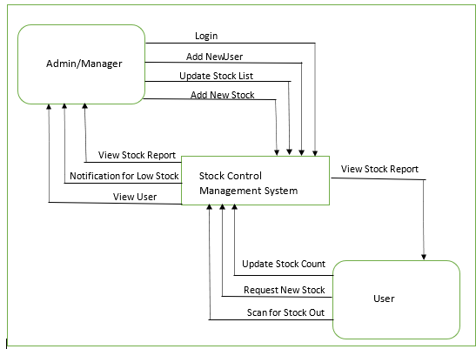

**Figure 1:** System Architecture

1. **RESULTS AND OUTCOMES**

## **Implementation**

In the Implementation stage of the study project, the characteristics of the stocks Control System were displayed through a website. The system has a variety of features, include login, enrollment, inventory, and many more. I created and saved the web document with HTML, then utilized CSS to create the attractive structure of the layout. Additionally, Bootstrap is utilized to make the design mobile and responsive. Furthermore, JavaScript and PHP are utilized to construct the system's website pages. MySQL is also used for accessing, manage and query the information stored in a database

**Screen Shots**

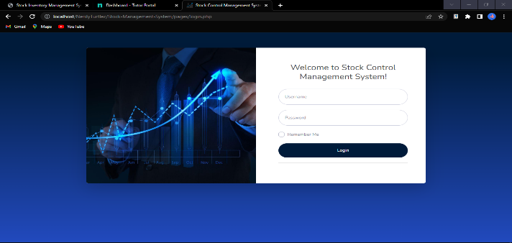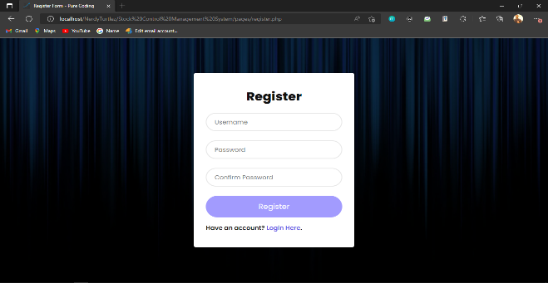

Login Page Registration Page

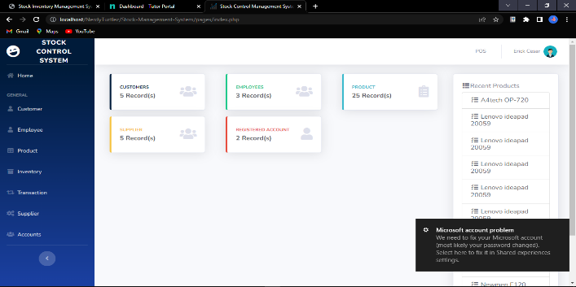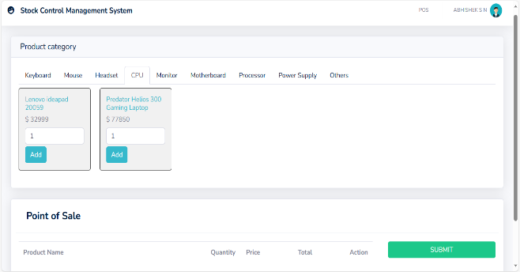

Home Page User Page

1. **CONCLUSION**

The technique is what matters most in making sure the system development process goes well. It is wise to employ one of the many various software development approaches available while creating a system. However, picking the appropriate approach is crucial since it will have an impact on how the system development process proceeds. If the proper methodology is applied to create a system, the project can be completed on schedule. Finally, every step of the process is clearly explained to make it easy to understand. In a system modeling and design, the specifics of the system's data flow and the entities involved are detailed, and every module is completely documented in relation to one another. While the Entity Relationship Diagram (ERD) and database design provide a clear grasp of the system's database and the relationships between each table, the Data Flow Diagram (DFD) design provides insight into the system's flow and straightforward explanations for each flow. The challenges will be resolved by the stock control management system since all inventoryrelated information will be recorded in a database, which will be much easier to maintain and update. This system will also help the organization save time and money by automating many inventory-related processes. stock control management system gives them all the information they need and want to grasp inventory-related matters quickly and easily. The inventory manager can use the system to list out all the specifics or to look through all the inventory data with this assistance

1. **REFERENCES**

* Software Engineering Tutorial. (2022). Retrieved July 17, 2022, from Tutorialspoint.com website: <https://www.tutorialspoint.com/software_engineering/index.htm>
* Wikipedia Contributors. (2022, June 8). Software engineering. Retrieved July 17, 2022, from Wikipedia website: <https://en.wikipedia.org/wiki/Software_engineering>
* Bontis, N., Crossan, M. M., & Hulland, J. (2002). Managing An Organizational Learning System By Aligning Stocks and Flows. *Journal of Management Studies*, *39*(4), 437–469. <https://doi.org/10.1111/1467-6486.t01-1-00299>
* Stock control and inventory. (2022). Retrieved July 17, 2022, from Infoentrepreneurs.org website:https://www.infoentrepreneurs.org/en/guides/stock-control-and-inventory/#:~:text=Stock%20control%2C%20otherwise%20known%20as,raw%20materials%20to%20finished%20goods.
* Melanie. (2017, October 17). The 5 Basics of Stock Control & How to Improve it. Retrieved July 17,2022, from Unleashed Software website: <https://www.unleashedsoftware.com/blog/five-basics-stock-control>
* What is Software Engineering? Definition, Basics, Characteristics. (2020, January 5). Retrieved July 17, 2022, from Guru99 website: <https://www.guru99.com/what-is-software-engineering.html>